Cabinet Committee on Performance Improvement
Meeting to be held on 6th December 2017

Electoral Division affected:
All

Customer Access Performance Report

Contact for further information:
Sarah Jenkins, (01772) 537401, Head of Service - Customer Access
sarah.jenkins@lancashire.gov.uk

Executive Summary

This report provides an update for the Cabinet Committee on Performance Improvement on the operation and performance of the Customer Access Service.

Recommendation

The Cabinet Committee on Performance Improvement is asked to comment on and note the contents of this report.

Background and Advice

The Customer Access Service (CAS) is the first point of contact for 60% of all incoming telephony and email enquiries to Lancashire County Council. Our Service strategic plan has been for additional services to be delivered by CAS, in order to better serve the citizens of Lancashire whilst improving costs and efficiency. The service is structured and divided into two distinct operational areas:

- Within the dedicated Social Care Centre, a highly specialised and sensitive service is delivered, offering information, advice and assistance on all matters relating to Adult and Children's Social Care. Requests ranging from simple ones, such as meals on wheels applications, are processed all the way through to handling more complex child and adult contacts.

- Within the Customer Contact Centre, twenty six services are delivered including: Highways, Ask HR, Libraries, Blue Badge, Registration, Crisis Support, Waste and Welfare Rights. Alongside these also sits a signposting service to direct customers to other agencies across the public sector, district councils and partner organisations.

The following table illustrates the volume of contacts presented for all services delivered through the Customer Access Service, April to September 2017, along with comparisons with the corresponding period from the previous year.

Customer Access Service overall performance – April to September 2017

Measure | 2016/17 | 2017/18
Telephone Calls Offered | 512,276 | 469,078
Telephone Calls Answered | 453,674 | 417,165
% Answered | 88.6% | 88.9%
emails Received | 91,806 | 93,433
emails Completed | 92,118 | 93,099
% Completed | 100.3%¹ | 99.6%
Total Contacts Received | 604,082 | 562,511
¹ This figure is over 100% due to a small carry-over of emails from the previous year.

The above table illustrates an overall reduction in calls answered, and an increase in emails processed. This is as a result of ongoing vacancies reducing the resource to answer calls, and also the increase in emails received in both the Customer Contact Centre and Social Care. Social Care emails are mainly from professionals and, at times, need follow up telephone calls or emails to progress, which requires more resource than dealing with merely a telephone call. CAS are working closely with both Children's and Adults Social Care to consider more effective and structured professional referral processes.

The reduction also reflects the successful ongoing campaign to assist channel change for services where it is appropriate, allowing effective self -service through the website. For example, for both Certificate Services and the Waste service, customers can complete transactions on line that previously were solely reliant on speaking to a Customer Service Advisor (CSA).

Calls into Adults and Children's Social Care have reduced, as a result of safer more effective referral pathways. The impact to Adults social care is influenced by the Newton's programme of pathway to independence. Similarly, with Children's social care, a change of process has been made at the front door, reducing the need for professionals to make repeat calls, by directing the contact to the most appropriate team at the first point of contact.

Both operational areas have a requirement for staff to handle all manner of requests of varying complexities and, as such, a comprehensive training programme is in place, supported by a commitment to their ongoing professional development. This in turn supports the delivery of a high quality service to customers, to meet and hopefully exceed their expectations.

CSAs are supported by a dedicated training team who provide bespoke training packages for each of the services provided.

We continually measure performance so that:

- We can tell that enquiries are handled without undue delay. This is as a result of the accurate forecasting of call volumes, by 15 minute intervals per day. We then compare the forecast to the actual performance.
- Customer experience is assessed, analysing data from our customer satisfaction surveys, and services re-engineered to deliver the optimum experience.

- Regular communication and feedback from senior managers is taken on board. We meet periodically with Heads of Service to discuss the specific service needs.

Performance, Transformation & Improvement

The service is actively involved with delivering requirements to support the following work areas within the above programme:

Children's Social Care

Contacts handled by CAS for Social Care have decreased overall, with a reduction in telephone calls but an increase in email contact. The reduction in calls in the main is as a result of the changes introduced earlier in the year, where professionals can now speak directly with social workers to discuss specific cases. This has resulted in a reduction of repeat and follow up calls.

- April to September 2017 - 61,938 contacts relating to Children
- April to September 2016 - 70,685 contacts relating to Children

Blue Badge Service

Improvements in application processing times, waiting times and the uptake of the Blue Badge online application system continues to be sustained in CAS.

The approval rate of Blue Badge applications so far this year is 81%.

As at the end of September 2017, there were a total of 54,331 Blue Badges in circulation.

The table below outlines the Blue Badge applications handled so far this year.

Blue Badge applications – April to September 2017

Month 2017 | Applications Received | Badges Awarded | Applications Declined
April | 1,269 | 1,070 | 199
May | 2,030 | 1,689 | 341
June | 1,548 | 1,291 | 257
July | 1,681 | 1,344 | 337
August | 2,029 | 1,599 | 430
September | 1,489 | 1,193 | 296
TOTAL | 10,046 | 8,186 | 1,860

LCC delivers the Blue Badge Service on behalf of the
Department for Transport (DfT) and, as such, has very strict guidelines which must be adhered to. The online application was introduced by the DfT in 2012. All Blue Badge applications have to be processed using the online processing system. Unfortunately, local authorities have little control over the online application. However, we have accounted that some applicants may find the online application process difficult, and we have therefore increased our offering of free internet access with some assistance in Lancashire libraries. We have developed a 'How to Apply' guide, to provide hints and tips to help customers navigate the online application, and to assist with some of the most common queries we receive with regards to the online application. CAS also offer a guided application service to assist applicants; between the 1st April and 30th September 2017, CAS have completed 1,161 applications in full on behalf of applicants and helped a further 2,000 callers with specific parts of the online application.

The Blue Badge Service continues to offer a fast track application process for terminally ill Blue Badge applicants (also known as palliative care applications). This fast track process includes:

- Applications being made on behalf of terminally ill customers, for example, by Macmillan Nurses and Hospice staff using a simple emailed form.
- Terminally ill applicants are not required to complete the usual online application form or submit any additional documentary evidence themselves.
- Palliative care applications do not require a photograph to be submitted.
- These applications are processed by the Blue Badge Service within 24 hours of receipt.
- A priority postal service is used to ensure customers receive their badge in the post as soon as possible.
- The £10 Blue Badge being waived for badges issued under the palliative care criteria.

Crisis Support

The administrative and financial delivery of the Crisis Support scheme was transferred into the CAS in January 2017.

To support the transition, the CSAs receiving telephone calls at the first point of contact have been trained on declining and signposting applications in specific circumstances, where the basic criteria for the service is not met.

The tables below illustrate the assistance provided by the Crisis Support scheme for the first two Quarters of 2017/2018.

Applications for assistance with food & fuel – April to September 2017

Period | Received | Awarded | Declined
April - June | 1,448 | 540 | 908
July - September | 1,135 | 380 | 755
TOTAL | 2,583 | 920 | 1,663

Applications for assistance with furniture – April to September 2017

Quarter | Received | Awarded | Declined
April - June | 354 | 239 | 115
July - September | 263 | 158 | 105
TOTAL | 617 | 397 | 220

Home Care Mobilisation

Lancashire County Council currently contract with approximately 190 home care providers, but from November 2017, we will be contracting with far fewer. The County Council believes this will improve the quality of home care services, whilst also offering more meaningful choice to people. It will mean a greater focus on standards, performance and monitoring. The changes may have an impact upon approximately 7,000 people, who have their home care managed by the County Council.

Some people will see a change in their home care provider, following the tendering process.

A dedicated telephone line within Customer Access (Social Care) has been set up to field enquiries from people who may be affected.

In September 2017, approximately 7,000 letters were sent out to people who could be affected by the changes. Of these, approximately half have been informed that their current care providers had been unsuccessful during tendering process. It is these people who we are expecting to contact us with enquiries.

During September, Customer Access received 1,425 calls from the public concerning Home Care Mobilisation. Calls are continuing to come in during October also.

Technology – blending emails and telephony contacts

As part of the development of the Genesys toolkit, Customer Access have overseen the implementation of HR and Children's Social Care emails onto the Genesys platform, in order to blend them with telephony contacts. These services previously handled all emails in Outlook, meaning that different systems had to be used alongside one another, and reporting produced manually on a daily basis.

Handling emails in Genesys has allowed more visibility of workloads, quicker handling times and more accurate forecasting and reporting. A project to move Adult Social Care emails onto Genesys is now being developed, following which all email contact throughout Customer Access will be successfully blended with traditional telephony contacts.

AskHR Service

A programme of work was launched following a request from Management Team to investigate increasing corporate uptake of, and improving provision of, self-service within Human Resources. One of the work streams identified was to review the hand off of work between the CAS and both Corporate HR and Payroll / Transactional services.

This review has led to the implementation of the corporately used Redmine system in October, allowing case management to be tracked between different service areas. The system provides updates through each stage of the process, and provides business intelligence on a variety of metrics which will support the evolution of the service moving forward.

Children's Social Care

As part of the development of the Multi Agency Safeguarding Hub (MASH) model within Children's Social Care, changes have been made to the referral process, in order to ensure that qualified social workers deal with concerns at the first point of contact. Customer Access have lead on this project, designing new processes, provided training for MASH social workers, and building a new set of telephony queues within the Genesys telephony system, to ensure that callers get through to the right person as quickly as possible.

The changes have generated efficiencies with the turnaround for Children's referrals decreasing and all referrals received by Customer Access being processed the same day. Liaison with partner agencies has taken place to support the changes which have generated positive feedback from a recent peer review, and are expected to receive similar feedback at the forthcoming Ofsted re-inspection.

Audit

In June 2017, the Internal Audit Team completed an audit of the adequacy and effectiveness of the controls and procedures in place over Blue Badge applications received by the CAS. A separate audit was completed on the 'Quality Assurance of Service Delivery in CAS.

The overall assessment for both audits received the 'substantial assurance' category noting there is a clear and comprehensive policy in place as well as a sound system of internal control that is operating effectively. The training, quality assurance and error logging processes were highlighted as contributing towards the effectiveness of the service.

Council Visits

Customer Access have hosted delegates from both Cumbria and South Lakes Councils during the summer of 2017, demonstrating the operational framework of customer contact within Lancashire.

The presentations illustrated a variety of aspects, focused on assisting the other authorities in developing and enhancing their own operations. These included strategies for improving the customer experience, as well as technical systems and aspects such as forecasting, training and change management. The feedback from both authorities has been exceptionally positive, with them feeling the visits were invaluable for them as they set off on their own journeys.
Highways Asset Management System (HAMS)

The new Highways system (HAMS) went live on 1 April 2017. Customer Access contributed significantly to the development and testing of the system, which replaces three existing systems. Customer Access trained over 60 advisors and Team Leaders in the use of the new system, and continues to work proactively with the service and Core Systems in the ongoing development of the system and supporting processes. In addition, a key focus of Customer Access has been to use the efficiencies inherent in the new system, to support a reduction in advisors' call handling times and thereby increase efficient use of resource.

Recruitment

Work has taken place with colleagues in the Corporate Communication team to design a dynamic and engaging recruitment advertisement, including profiles on existing staff and their experience working for LCC. The new advert has been well received by applicants, demonstrating the benefits of working for the authority.

The table below illustrates the number of Customer Service Advisors recruited so far during 2017/2018.

Customer Service Advisors recruited – April to September 2017

Period | Customer Contact Centre | Social Care | HR
April – June | 3 | 13 | 0
July - September | 9 | 4 | 0
TOTAL | 12 | 17 | 0

With a further 30 new starters scheduled to start their induction programmes during October to December.

Training

The table below illustrates the number of Training Sessions that have taken place so far during 2017/2018, along with the number of Advisors who have been trained.

Advisors trained – April to September 2017

Service Area | Customer Contact Centre |  | Social Care |  | HR
Period | Sessions | Agents | Sessions | Agents | Sessions | Agents
April - June | 17 | 80 | 12 | 104 | 0 | 0
July - September | 23 | 161 | 24 | 92 | 7 | 23
TOTAL | 40 | 241 | 36 | 196 | 7 | 23

Automated Customer Satisfaction Surveys

Customers are offered the opportunity to complete a survey based upon their perception and opinion of the service they experience during their contact with the council. This provides an unbiased gauge and view of the service we deliver.

In the period April to September 2017, 12,548 Customer Satisfaction surveys were completed. The tables below provide a breakdown the percentage of calls which were resolved at first point of contact from a customer perspective, and also the overall customer satisfaction experienced.

Resolved at first point of contact – April to September 2017

Service Area | % of Calls Resolved at the First Point of Contact | Number of Reponses
Customer Contact Centre | 79.2% | 9,162
Social Care | 75.5% | 2,495
AskHR | 85.4% | 1,211

Overall customer satisfaction experienced – April to September 2017

Service Area | % score for  Customer Satisfaction | Number of Reponses
Customer Contact Centre | 82.0% | 8,941
Social Care | 79.7% | 2,417
AskHR | 88.3% | 1,190

Compliments and Complaints

The number of overall compliments the Customer Access Service has received so far during 2017/2018 is 23. The number of complaints received so far during 2017/2018 is 27 out of a total number of 557,816 contacts received.

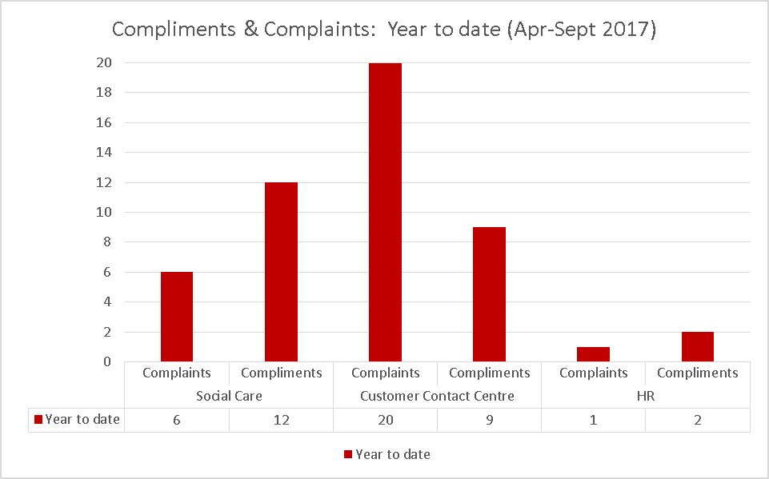

Telephony & email Performance

Telephony performance – April to September 2017

Telephony performance – July to September 2017

Email performance – April to September 2017

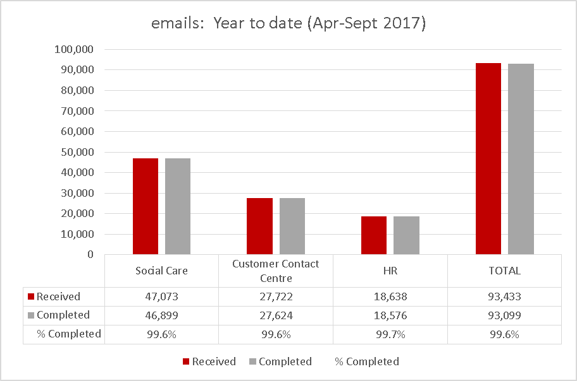

Email performance – July to September 2017

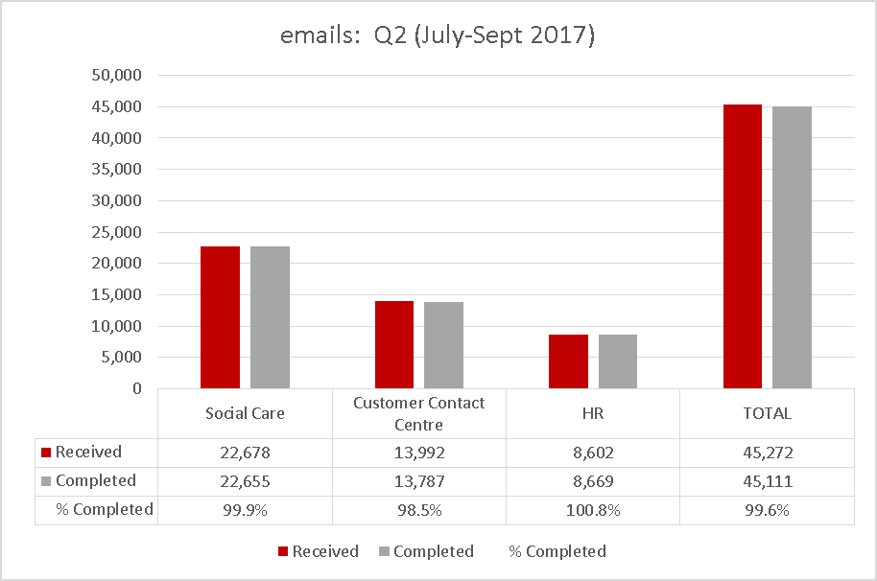
HR % Completed figure is over 100% due to a small carry-over of emails from the previous period.

Future Improvements

Genesys New Technology – Phase 2

In September 2016, the Customer Access Service oversaw the implementation of the new Genesys platform which supported enhanced multi-channel contact for customers of LCC. The platform is also used by the LCC Accounts Payable and Procurement Services, Emergency Duty Team, MASH Children's Services, and BTLS AskICT.

The Genesys Project is currently within Phase 2, where the focus is on implementing brand new functionality such as telephony Auto-Attendant, as well as new channels of contact such as Web-Chat and Social Media. Concurrently, the service is also dedicating work to utilising the Genesys platform to improve existing services, including blended emails and real-time queue management.

Liquid Logic – Early Help Module

Customer Access are currently working in conjunction with other services on the implementation of the Early Help Module within Liquid Logic. This project will include the redesign of the front door and incorporate SEND and EHCP processes along with Wellbeing, Prevention and Early Help.

Customer Access are contributing to the design of both the revised processes and the technical configuration of the system, and will be heavily involved in the testing of the resulting solution. With an expected go live of September 2018, the Early Help module will enable better partnership working and a coherent transition between all stages of intervention throughout the different services of the authority.

Crisis Support Changes

The Crisis Support Service delivers care and urgent need support to residents of Lancashire who may require assistance with food, energy or furniture. Customer Access are currently managing changes to the service in order to ceasing the cash voucher payments currently provided and provide food parcels to customers instead.

Engagement work will be undertaken with individuals with the goal of breaking the cycle of support and enabling self-management and stability.

NoWcard Renewals

At the end of October, we entered into the NoWcard re-issue period which is a large renewal event which happens every 5 years. This is a very busy time for the CAS as we assist customers whose badges expire on 31 March 2018 to renew their passes. This year there is a total of 180,000 and, as a result, we will experience a large increase in call volumes for this service.

We have been working with our colleagues in the NoWcard Bureau to ensure all our information is up to date, and to agree letter distribution which will see 6,000 letters going out each day. To ensure we give the best service possible we have completed additional NoWcard training.

Blue Badge Improvements
We have recently taken part in a review to determine whether the key internal controls relating to quality assurance within the Customer Access Service were adequately designed and effectively operated by our internal audit team. Overall, they were able to provide substantial assurance on the adequacy and effectiveness of the controls in place for quality assurance within the CAS. Following on from the audit, we are working on an improvement plan, which will involve reviewing some of our processes and, in particular, our correspondence to improve the customer experience. We have also recently held a meeting with County Councillor Buckley and a representative from Citizen Advice, and will look to make improvements based on the points raised by Citizen's Advice which we have added to our overall improvement plan.

Winter Refresher
As part of our commitment to the Highways service, Customer Access will deliver winter refresher briefings in November to all trained advisors covering key areas such as gritting and flooding. This briefing enables the advisors to deliver updated information and guidance to customers, and to support the Highways service during the winter months. These refreshers are delivered each year and have proved their worth during the usual challenges of winter and in times of exceptional weather such as the floods of winter 2015/16.

Customer Access Service Plan and Vision

The 2017/18 service plan will support a customer focused approach to service delivery contributing to and enabling the authority's Digital Strategy. It will also demonstrate the CAS contribution and commitment to the council's key Customer Access objectives, of increasing and improving 'access channel change', reducing the cost of service delivery by promoting self-service and automation for specific services and ensuring that the services provided keep the citizens of Lancashire at the core of what we do. However, customers will not be excluded because they do not have internet access at home. Where appropriate, our most vulnerable citizens will have telephone access to CSAs who understand specific services areas.

Children Not in Education, Employment or Training (NEET)

CAS are currently working with the Learning & Skills Service in order to provide a clearer picture on data for young persons aged 16-19, not in education, employment or training – known as NEET. This will involve liaising with young people as well as parents and guardians, employers, and education and training providers, and will also consider different methods in order to maximise engagement. This is an ongoing piece of work and will focus on a cohort of around 2500 young people (10% of all school leavers) currently listed as either NEET or with an unknown status, in order to ensure data accuracy; allowing the Learning & Skills Service to focus on particular areas of need to reduce NEET numbers going forward. The proposal is that this element of work will transfer to CAS in the new financial year.

Family Information Service (FIS)

CA are working closely with Communications and FIS to develop, promote and, in turn, increase uptake and use of the service via the website. The service will review and increase the scope within CA and also on the website which, in turn, will reduce the workload impact on the back office. The plan will also look to utilise more effectively the teams within LCC that have face to face contact with some of our more vulnerable families, with a view to increase uptake of child care arrangements.

Adult Safeguarding

A review in partnership with the Adult MASH team which will include re-engineering processes and adapt lessons learned from the new agreed safer ways or working around Children's referrals, has been agreed.

Consultations

Internal/external customers and service areas, including CAS and HR staff.

Implications:

This item has the following implications, as indicated:

Risk management

This report is for noting and therefore a risk analysis in relation to the content on this report has not been required.

Financial Implications

There are no financial implications arising from this report.

Local Government (Access to Information) Act 1985

List of Background Papers

Paper | Date | Contact/Directorate/Tel
Nil
Reason for inclusion in Part II, if appropriate

N/A

